2.2 Planning Proposal to amend Orange Local Environmental Plan 2011 - rezoning of 185 Leeds Parade

RECORD NUMBER:

AUTHOR: Craig Mortell, Senior Planner

**EXECUTIVE Summary**

Council has received a proposal to rezone part of Lot 4 DP 1185665, known as 185 Leeds Parade, situated on the intersection with the Northern Distributor Road. The site is currently a combination of IN2 Light Industrial and SP3 Tourist zones, and the proposal seeks to increase the extent of SP3 Tourist zone.

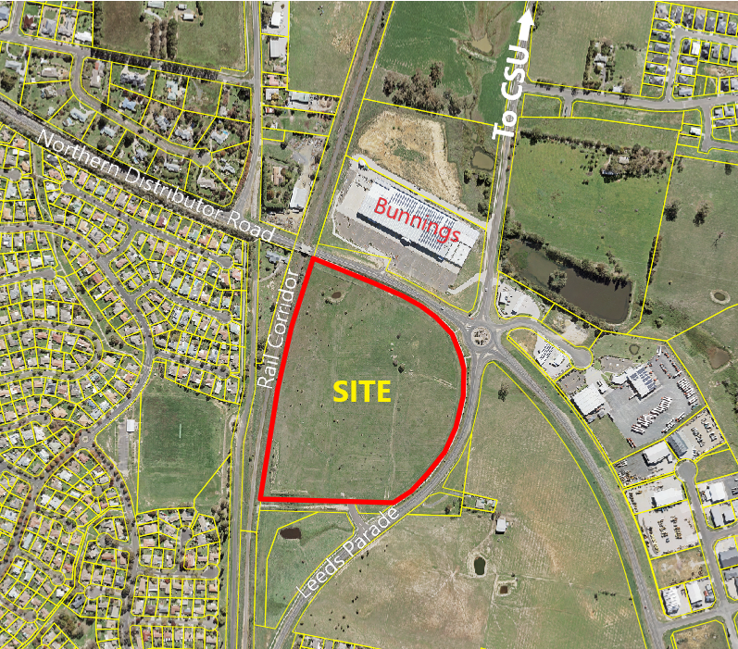

**Figure 1 – locality plan**

Development for a highway service centre (truckstop) has recently been approved (DA 332/2019(1)) within the existing SP3 Tourist zone, and the proponents are seeking to collocate similar and complementary forms of development over more of the site. This would consist of four fast food outlets along the NDR frontage with other forms of highway related development to occur into the future.

The nominated SP3 zone allows only limited forms of commercial development and is therefore not likely to impact upon the trading performance of the main CBD, but instead provides opportunity to recapture trade from passing through traffic while also extending the range of services available to North Orange residents.

**Link To Delivery/OPerational Plan**

The recommendation in this report relates to the Delivery/Operational Plan strategy “7.1 Preserve - Engage with the community to develop plans for growth and development that value the local environment”.

**Financial Implications**

Nil

**Policy and Governance Implications**

Nil

*Do not delete this line*

|  |
| --- |
| **Recommendation**  **1 That Council resolve to support the planning proposal, enabling the matter to be progressed through to the Gateway process; with staff to forward the matter to the Department of Planning, Industry and Environment for assessment.**  **2 That the matter then proceed in accordance with any requirements or conditions of a Gateway Determination before being returned to Council once the public and agency consultations have been concluded.**  **3 That Council require the site to be subject to a Development Control Plan in the form of a masterplan that addresses:**   * **Urban design outcomes with respect to the presentation of the site to the frontages of Leeds Parade and the Northern Distributor Road.** * **Measures to address potential acoustic impacts emanating from the site.** * **Pedestrian and cyclist linkages and permeation of and through the site.** * **Size, height and number limits on the extent of pylon signs, as well as appropriate and preferred locations for such signs.**   **4 That the proponent be advised of the need to prepare a masterplan addressing the above matters, to enable future development of the site to proceed in an orderly manner.** |

*Do not delete this line*

**further considerations**

Consideration has been given to the recommendation’s impact on Council’s service delivery; image and reputation; political; environmental; health and safety; employees; stakeholders and project management; and no further implications or risks have been identified.

**SUPPORTING INFORMATION**

**Site Description and Context**

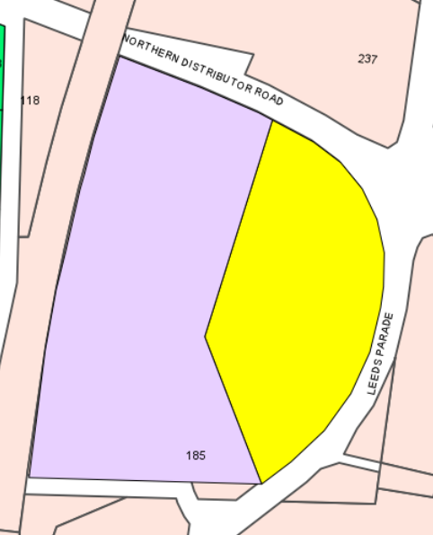

**Figure 2 – current extent of zones on the subject land**

**(purple is zone IN2 Light Industrial – yellow is zone SP3 Tourist)**

The subject land is 12.2ha on the corner of the Northern Distributor Road and Leeds Parade. The western boundary is formed by the Great Western Railway corridor and the southern boundary adjoins the former alignment of Leeds Parade. The terrain is gently undulating with a fall towards to the south-western corner.

To the north, across the NDR, is the Bunnings Warehouse site. Northeast of the site is Hanrahan Place, which connects directly to the roundabout via a fifth leg exit, contains two existing highway service centres and leads to a logistics facility at the end of Hanrahan Place. Undeveloped residential land is to the east, across Leeds Parade. South of the site is undeveloped B6 Enterprise Corridor land and northwest of the site, across the railway corridor, is an industrial zoned site that contains an existing dwelling, beyond which are more residences.

**STRATEGIC PLANNING CONTEXT**

Consistency with the Blayney Cabonne Orange Sub-Regional Rural and Industrial Strategy is considered to be satisfactory. While the site is identified in that strategy as industrial rather than highway services, the overall intent is employment generation. In that sense this site has potential to recapture trade from highway travellers due to its exposure to the Northern Distributor Road, a factor that other industrial/employment lands cannot match. Therefore the opportunity for highway service related employment is not able to be pursued at other locations, whereas generic industrial employment can be attained at alternative sites.

**Objectives of the Zone(s)**

The objectives of the SP3 Tourist zone are:

* *To provide for a variety of tourist-oriented development and related uses.*
* *To cater for the needs of the travelling public.*

In the Orange context the SP3 zone has been deployed at limited sites along the Northern Distributor Road specifically to enable proposals that service the highway/through traffic. Such traffic uses the NDR to avoid navigating the central areas of Orange, which is of benefit to local traffic conditions, but also reduces the economic benefits to the local economy from these travellers. By enabling specific sites along the NDR to cater to the needs of travellers this economic potential can be recaptured without undermining the performance of the CBD.

* *The objectives of the IN2 Light Industrial zone are:*
* *To provide a wide range of light industrial, warehouse and related land uses.*
* *To encourage employment opportunities and to support the viability of centres.*
* *To minimise any adverse effect of industry on other land uses.*
* *To enable other land uses that provide facilities or services to meet the day to day needs of workers in the area.*
* *To support and protect industrial land for industrial uses.*

The IN2 zone on the site is derived from the historical industrial zoning of the entire zone under the former LEP 2000. This was selected over the IN1 zone when LEP 2011 was drafted in recognition that general industry would not be well suited adjacent to a successful development in the SP3 zone.

The current split of IN2 and SP3 was created without the benefit of a specific concept plan in place, and both the configuration and ratio were therefore always subject to adjustment.

Fundamentally the strategic intent for this site has always been for employment generating purposes. The nature of the jobs to be created at the site (industrial versus service oriented) is not considered to be a significant factor in this case as there is a clear need to recapture trade from through traffic, and such facilities are also able to expand the range of services to the local North Orange/Waratah population.

**TRANSPORT AND TRAFFIC**

**Northern Distributor Road**

Council’s Technical Services Division have reviewed the planning proposal and raised no objections. The internal road linking the site from Leeds Parade to the Northern Distributor Road has also been considered during assessment of the truckstop (DA 332/2019(1)). The approved internal road through the site from Leeds Parade would include a left-in left-out connection to the NDR, reducing the extent of traffic turning at the roundabout. The traffic impact assessment states that the cumulative development of the site is anticipated to generate 544 and 798 vehicle trips per hour in the morning and evening peak periods respectively, with an estimate of 50% being passer-by trips; and modelling indicates that the proposed access points will operate well.

**Local Traffic**

While the proposal is fundamentally aimed at servicing through traffic, local traffic flows past and around the site are a significant factor. This consists of traffic between the city centre and Charles Sturt University Campus, as well as traffic drawn to the Bunnings site on the other side of the NDR. East-west local traffic flows are related to the North Orange Shopping centre and Waratahs sporting complex, both accessed via Telopea Way.

The majority of vehicle movements into and out of this site are likely to be derived from existing traffic flows rather than the site becoming an attractor in its own right. To the extent that the development does attract new traffic, a substantial amount would come from the south along Leeds Parade and therefore have limited impact on the operation of the NDR. North Orange residents would be the exception, and this may result in an increase in the number of east-bound NDR vehicles opting to turn right at the NDR/Leeds Parade roundabout. Such vehicles leaving the site would use the internal road connection with the NDR and thus not impact on the roundabout.

**Public Transport**

The internal road connecting Leeds Parade to the NDR provides a suitable option for bus and taxi operators that removes them from the broader traffic flows along the NDR/Leeds Parade. As such, it is considered that the site can be readily served by public transport options.

**Cycle and Pedestrian Movement**

A public footpath exists along the entire frontage of the property, both the NDR and Leeds Parade. The slope of Leeds Parade in this area is likely to discourage pedestrian usage. However, the permeability of the site, due to the approved internal road between Leeds Parade and the NDR, would provide an improved connection for pedestrians and cyclists between the city and North Orange.

**ENVIRONMENTAL CONSIDERATIONS**

**General**

The site is not considered to be at risk of bushfire, landslip or erosion. The site is not known to be contaminated from past uses and there is no significant flora or fauna on the site due to its history of grazing.

**Noise Impacts**

The site is located alongside and to the east of the rail corridor. While the proposal itself relates to non-residential development, building forms will need to be set back from the corridor to reduce any potential for rail vibrations to impact on the structures. Beyond this there are residences further to the west of the rail corridor, as well as undeveloped residential land to the east of the site across Leeds Parade.

The setbacks from the rail corridor can also serve to protect residents to the west, and future development of the site could include screen landscaping to assist in this regard. Residential land to the east is buffered by the width of Leeds Parade itself, as well as the front setbacks that would be anticipated. The generous size of the site enables a wide range of design responses.

It should be noted that the employment land status of the site is long established, and both current and future residents would have anticipated that some industrial or highway type of development would eventuate. The proposal, in seeking to increase the tourism zone, is reducing the potential industrial developments that could otherwise have occurred, and this may lead to a modest reduction in potential noise generated.

The likely hours of operation of the takeaway food and drink premises mean that the timing of noise emissions, rather than the absolute volume, could be a concern for residents. Preliminary site designs have sought to respond to this concern by facing activity inwards towards the internal road corridor (approved under the truck stop application). This would allow the building forms to act as sound barriers and can be supplemented by perimeter sound mounds and landscaping as needed.

A more detailed assessment of, and response to acoustic impacts would be expected during the subsequent DA, but it is evident that there is scope within the site to respond well to this constraint.

**Stormwater Management**

The planning proposal has reserved the south-western corner of the site for a potential detention basin. This would be scaled to suit the development as required during a DA process. The presence of the NDR to the north acts to limit the catchment effectively to the site itself. This enables the future development to be designed with confidence as to the extent of runoff and detention required.

**Land or Site Contamination**

The historic use of the site and a site inspection have not revealed any potential for land contamination. The zone being sought is not of a residential nature and is likely to have extensive sealing. Accordingly, contamination is not considered to be a concern for this proposal. More investigation can be required at the DA stage to confirm this view.

**Flooding**

Council conducted the Blackmans Swamp Creek and Ploughmans Creek Flood Study in 2019 to inform its planning and land management obligations. The study introduced and mapped overland flow flooding, in addition to riverine flooding, to the areas mapped for flood planning controls.

As indicated in the aerial image below, a modest dam exists in the north-western corner of the site, overflow from which feeds into a drainage path extending north-south toward the western third of the site, which in turn leads to a larger depression in the south-western corner of the site. From there water flows into drainage lines alongside the rail corridor.

The concept plan submitted in support of the proposal has allowed space for a detention basin in the southwest corner of the site which can be scaled to suit the extent of potential development.

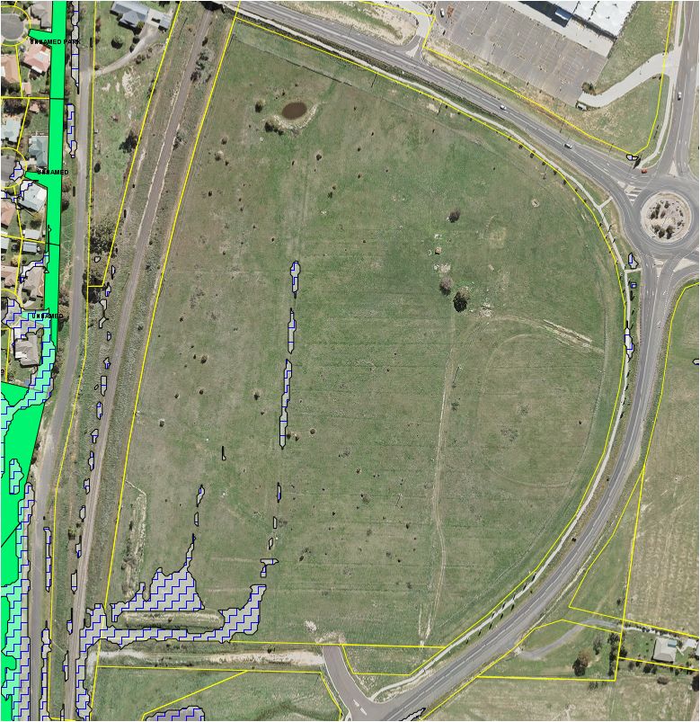

**Figure 3 – flood status of the subject land as per the**

**Blackmans Swamp Creek and Ploughmans Creek Flood Study**

**URBAN DESIGN CONSIDERATIONS**

The concept plan layout is preliminary and indicative only. It shows the likely pattern of creating clustered buildings either side of the internal access road. This suggests that the built form will be oriented to face inward, which will reduce potential noise impacts to surrounding areas but risks presenting extensive amounts of back-of-house building bulk to the NDR/Leeds Parade frontages.

The commercial nature of the site and its exposure to the NDR is likely to see additional advertising and signage form part of the development. Given the difference in elevations between the NDR and the subject land, this could result in pylon signs of significant height in order to appear at an appropriate level when viewed from the NDR. The visibility of such signage would extend well beyond the immediate area and potentially impact on the views of residents even some distance from the site.

Accordingly, a Site specific Development Control Plan should be considered prior to any additional development applications on the site. Such a DCP would enable the visual bulk and presentation of the site, and the advertising and signage requirements to be properly integrated into the development. The DCP would also be able to ensure that pedestrian and cyclist permeability is catered for up front as the internal access road is likely to be regarded as a short cut to North Orange by many people.

**ECONOMIC CONSIDERATIONS**

**Potential to Conflict with the CBD**

Council has a long standing position of seeking to protect and enhance the trading performance of the CBD. Avoiding fragmentation, particularly of retail premises, helps to consolidate trade in the CBD, which draws more shoppers from further afield than would otherwise be the case. This approach keeps our CBD as an important regional centre and a greater range and number of businesses to be viable than would normally be supportable by just the local population.

**Employment Land**

The site has long been identified for employment generating uses; prior to Orange LEP 2011 the site was industrially zoned. When LEP 2011 was prepared the NDR was nearing completion and the site was identified as a suitable location to serve highway and through traffic. Consequently the SP3 Tourist zone was adopted for a portion of the site in anticipation of demand for highway service centre style development.

**SOCIAL AND CULTURAL CONSIDERATIONS**

The site is not known to contain any Aboriginal or European archaeological or heritage values.

While not zoned for or including any specific public open space, it is likely that in the near to mid term much of the site will remain undeveloped. In the longer term the south-western corner of the site will in all likelihood be retained as a stormwater detention basin, and could therefore be designed to serve a dual purpose of drainage and open space.

Social and cultural impacts are considered to be negligible as there are no existing residences on the site. The vacant nature of the site and the absence of significant flora and fauna mean that the site is not likely to have become highly valued by the broader community.

Stakeholder engagement will be undertaken in accordance with Gateway requirements and is likely to include consultation with John Holland Rail and Transport for NSW. General public engagement will include the public exhibition process in due course.

**INFRASTRUCTURE CONSIDERATIONS**

Council’s engineering section have raised no objection to the planning proposal.

**CONSISTENCY WITH STATE PLANS AND POLICIES**

**Section 9.1 Ministerial Directions**

**1.1 Business and Industrial Zones**

This direction applies when a planning proposal will affect land within an existing or proposed business or industrial zone.

The intent is to encourage employment growth in suitable locations, protect employment land and support the viability of identified centres.

When the direction applies a planning proposal must:

(a) give effect to the objectives of this direction;

(b) retain the areas and locations of existing business and industrial zones;

(c) not reduce the total potential floor space area for employment uses and related public services in business zones;

(d) not reduce the total potential floor space area for industrial uses in industrial zones; and

(e) ensure that proposed new employment areas are in accordance with a strategy that is approved by the Secretary of the Department of Planning, Industry Environment.

However, a planning proposal may be inconsistent with the direction where justified by a relevant strategy, study, Regional or Sub-regional plan, or if the inconsistency is demonstrated to be of minor significance.

**Comment:** The proposal retains the land for employment generation. The nature of the employment to be generated may be different, but this is due to the site specific potential to serve the tourist, passing highway traffic which is not attainable at other sites. It should be noted that the Blayney, Cabonne Orange Sub-regional Strategy is currently being reviewed and has not indicated that Orange is lacking in industrial land supply.

Therefore to the extent that this proposal will remove a portion of an industrial zone it is considered to be of minor consequence as it will be replaced by another employment generating zone.

**3.4 Integrating Land Use and Transport**

This direction applies when a planning proposal will create, alter or remove a zone or provision related to urban land for residential, business, industrial, village or tourist purposes.

The intent is to improve access to housing, jobs and services by walking, cycling and public transport; increase the choice of available transport and reduce dependency on cars; reduce travel demand; support efficient and viable public transport services; and provide for the efficient movement of freight.

When the direction applies a planning proposal must locate zones for urban purposes and include provisions that give effect to the aims, objectives and principles of:

(a) Improving Transport Choice – Guidelines for planning and development (DUAP 2001); and

(b) The Right Place for Business and Services – Planning Policy (DUAP 2001).

However, a planning proposal may be inconsistent with the direction where justified by a relevant strategy, study, Regional or Sub-regional plan or if the inconsistency is demonstrated to be of minor significance.

**Comment:** The planning proposal is considered to be consistent with this direction

**4.3 Flood Prone Land**

This direction applies when a planning proposal will create, remove or alter a zone or provision that affects flood prone land.

The intent is to ensure that development of flood prone land is consistent with the NSW Government’s Flood Prone Land Policy and the principles of the Floodplain Development Manual 2005, and ensure that the provisions of an LEP on flood prone land is commensurate with the flood hazard both on and off the subject land.

When the direction applies a planning proposal must

(a) include provisions that give effect to the Flood Prone Land Policy and associated Floodplain Development Manual;

(b) not rezone land from special use, special purpose, recreation, rural or environmental protection zones to residential, business, industrial or special use/special purpose zones;

(c) permit development in floodway areas, or that will result in significant flood impacts to other properties, or permit a significant increase in the development of that land, or be likely to result in a substantially increased requirement for government spending on flood mitigation, or permit development without consent except for agriculture, roads or other exempt development;

(d) not impose flood related controls on residential development without adequate justification; and

(e) not set or determine a flood planning level inconsistent with the Floodplain Development Manual 2005 without adequate justification.

However, a planning proposal may be inconsistent with the direction where the proposal is shown to be in accordance with a floodplain risk management plan or otherwise justified by a relevant strategy, study, Regional or Sub-regional plan or if the inconsistency is demonstrated to be of minor significance.

**Comment:** The extent of flooding identified in the recent flood study is minor and reflects the topography of the site from an overland flow perspective. The concept plan reflects the pattern of overland flow occurring on the site, and has provided space for a detention basin in the south-western corner of the site consistent with the anticipated flooding behaviour. Additionally, the proposal is not seeking to establish new or additional employment lands, but rather to adjust the nature of already zoned land.

**5.10 Implementation of Regional Plans**

This direction applies to all planning proposals. The intent is to give legal effect to the vision, land use strategy, goals, directions and actions contained in Regional Plans.

When the direction applies a planning proposal must be consistent with the relevant Regional Plan.

However, a planning proposal may be inconsistent with the direction where justified by a relevant strategy, study, Regional or Sub-regional plan or if the inconsistency is demonstrated to be of minor significance.

**Comment:** The planning proposal is consistent with the Central West and Orana Regional Plan.

**6.3 Site Specific Provisions**

This direction applies when a planning proposal will allow a particular development to be carried out. The intent is to discourage unnecessarily restrictive site specific planning controls.

When the direction applies a planning proposal must allow the intended use to be carried out in the zone the land is situated on, or rezone the site, or allow the land use on the relevant land without imposing any development standards or requirements other than those already applying to the land or zone concerned. Additionally, a planning proposal must not contain or refer to drawings that show details of the development proposal.

However, a planning proposal may be inconsistent with the direction where justified by a relevant strategy, study, Regional or Sub-regional plan or if the inconsistency is demonstrated to be of minor significance.

**Comment:** The planning proposal is consistent with this direction. A site specific Development Control Plan is considered appropriate to allow for urban design outcomes to be clearly articulated and expressed to help inform the design of built form across the site. Such a DCP should not be viewed as adding site specific provision in this sense, but rather serve to clarify the expectations of the community that are already required under DCP 2004.

**SEPP 64 Advertising and Signage**

Subsequent development of the site for commercial land uses, allowed under the SP3 Tourist zone, is likely to include prominent advertising and signage. Because the NDR is not a classified road, consultation with Transport for NSW (formerly RMS) would not be triggered. However, as traffic volumes on the NDR continue to rise it is likely that the NDR may become a classified road at some future point. Therefore the provisions of schedule 1 of the SEPP, which provide a useful set of criteria to evaluate signs, should be considered during subsequent DAs.

**SEPP (Infrastructure) 2007**

The SEPP contains requirements to consult with the rail authority where certain development is to occur within or adjacent to a rail corridor. While it is unlikely that the subsequent DA would trigger these requirements, the rezoning would have that potential. Therefore it is anticipated that a Gateway Determination would include a requirement to consult with the rail authority.

The SEPP also contains provisions relating to Traffic Generating Development. Essentially this consists of a set of trigger points, such as traffic volumes or parking spaces for different forms of development. If triggered by a DA the matter needs to be referred to Transport for NSW (formerly RMS) for consideration. While it cannot be determined during the planning proposal stage, there is a distinct potential for the site to reach those thresholds. Consequently it is anticipated that a Gateway Determination would include a requirement to consult with Transport for NSW.

**ANTICIPATED PROJECT TIMELINE**

**Gateway Process**

Should Council resolve to proceed, the planning proposal and associated documents will be supplied to the Department of Planning, Industry and Environment for evaluation under the Gateway process. This typically takes 4–8 weeks, but can vary considerably in both direction. Once issued the Gateway Determination will outline the remainder of the process. This typically includes:

* Whether the Minister will delegate the power to make the plan to Council or withhold such delegation (typically in cases where the Council has a direct interest in the site or matter concerned).
* Any additional information or changes to the planning proposal required before consultation and exhibition can proceed.
* A list of government departments and agencies that are to be consulted.
* The public consultation and exhibition periods (typically 28 days).
* Whether a public hearing is required (typically only applies to reclassification of Council owned or controlled land under the *Local Government Act 1993*).
* Formal drafting of the amendment through Parliamentary Counsel.
* Finalisation of the amendment by publishing the change on the legislation website.

**Agency Consultation**

Given the site location and nature of the planning proposal, it is anticipated that the Gateway Determination may require consultation with Transport for NSW (formerly RMS) and John Holland Rail.

**Community Consultation**

Typically a 28 day public exhibition period is required. All materials will be made available on Council’s website and at the Civic centre for inspection during the required period.

**Post Exhibition Evaluation**

Once the exhibition period has concluded, all submissions received (from both the community and agencies) will be collated and reviewed. Issues identified in the submissions are then evaluated for significance, and where appropriate the proponent will be invited to respond, which may include relevant changes.

**Report and Finalisation**

Once all submissions have been reviewed, a further report to Council will be prepared to outline the response of agencies and the community, as well as any suggested adjustments. Council retains the option to reject a planning proposal at any time up to and including the final report. However, if endorsed the matter is then finalised, either by the CEO under delegation from Council or by the Department of Planning, Industry and Environment in cases where the Gateway Determination withheld delegations from Council.

*Do not delete this line*

**Attachments**

1 Planning Proposal - 185 Leeds Parade - December 2019, D20/27717

2 Planning Proposal - Site and Context Plans, D20/27718

3 Planning Proposal - Concept and Zone Plan, D20/27719

4 Planning Proposal - Traffic Impact Assessment, D20/27720

5 Planning Proposal - Acoustic Assessment, D20/27721

6 Planning Proposal - Environmental Site Assessment, D20/27722